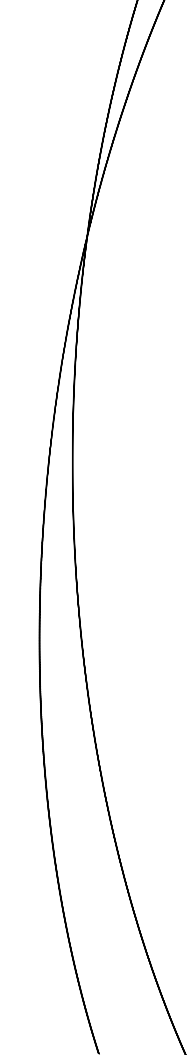
university of cincinnati

Department of Biological Sciences

Internship Learning Agreement

Student Name: M number: _______
Email: Phone:

Organization Name:
Organization Address:
Supervisor: Supervisor Title:
Phone: Fax: Email:

Learning Goals/Outcomes of Position

Duties and Responsibilities of Intern:
- To complete all assignments, job related tasks ,and hours required by the internship agreement and intern organization.

university of cincinnati

Department of Biological Sciences
Duties and Responsibilities of Supervisor:

- To meet with the intern regularly to evaluate performance and provide constructive feedback.

- To help intern achieve learning goals as listed above by providing meaningful work.

- To provide resources for intern to allow him/her to learn about the organization and industry that he/she is working in.

- To submit an internship evaluation upon completion of student internship.

Learning Goals & Outcome Achievement will be measured in the following ways:

Schedule for work each week (as of completion of this form):
Monday | Wednesday | Saturday
Tuesday | Thursday | Sunday
 | Friday

Starting Date of Internship: Ending Date of Internship:
Number of hours of work/week:
Compensation (if applicable):
Intern Signature: Date:
Supervisor Signature: Date:
UC Faculty Signature: Date:

